Welcome Pack
Train Together Functional Fitness Studio
Harper’s Mill
White Cross Business Park
Lancaster
LA1 4XQ
01524389616 / 07725482701
info@traintogether.co.uk

CONTENTS
About Us | 2
Our Classes | 3
Time Table and Gym Information | 4 - 6
Memberships and Prices | 7
Personal Training | 8
Our Programmes | 9
Testimonials | 10 – 12
Our Fitness Courses | 13
First Aid and Manual Handling Courses | 14
How to Find Us | 15

ABOUT US
At Train Together we are passionate, supportive and encouraging trainers focused entirely on helping our clients reach their fitness goal in a manageable, fun and, most importantly, healthy way.
We have a superb range of equipment and a brilliant variety of classes to get stuck into- from energetic boxercise to classy core, from HIIT to weight lifting! We keep our class sizes to a maximum of 8 - 12 people – ensuring that we can always provide exceptional personal attention to every client at a fraction of the cost.
With over 30 years’ experience, you can be confident you are in very safe hands with us!

Neil Caines and Sarah Grant
Co-Owners and Personal Trainers
Train Together Functional Fitness Studio

OUR CLASSES
Abs Conditioning – a faster paced Abs class hitting the whole core, front and back.
Blast Class – (for the not so early starters!) A great variety, all fitness levels catered for.
Bootcamp – fast-paced and plenty of variety. A class designed to build strength, burn fat and challenge you.
Boxercise – exercise based around non-contact boxing moves and fitness. Great for coordination and stamina.
Cardio/Power Hour – 60 minutes using a variety of cardio machines and weights/resistance.
Circuits – selection of body weights, free weights and cardio machines. Fast-paced class to work every part of the body that hits all the right notes – fitness, strength and endurance.
Core – based around working the whole core. Not just the abs, it’s designed to strengthen the whole midsection, front and back.
HIIT – High Intensity Interval Training. Short bursts of exercise with even shorter rest periods. Very intense!
HIRT – slightly different to HIIT in that there will be more weights/resistance used. Still intense though!
Indoor Cycling – great workouts on the bikes. Intense and sweaty!
In Shape – a 6 weeks body transformation program. A separate sign up not included in the “normal” classes memberships. Speak to Sarah for details.
Kettlebells – fantastic workout for testing strength and stamina. Glutes and Hamstrings worked.
Mega Stretch – end the week with a gentle stretching session to reduce tension and improve flexibility.
Metabolic Conditioning Circuit – a fast paced, intense workout for boosting the metabolism.
MetaFit – a fast paced, body weight HIIT style class. Great workout, that is tailored to your ability.
Pilates – a great class offering core & strength training at a different pace to the others on offer!
Swiss Ball Circuit – working out with stability balls – one of our more popular classes. Low impact and a fantastic whole-body workout. Great fun!
Total Toning – it’s in the name! Full-body, intense workout (not for the faint hearted!)
Weight Lifting – very popular classes (especially with the ladies)! Great workouts with bars, dumbbells and kettlebells. Split in to either lower body for legs and glutes. Upper body for chest, shoulders and back or an all over, full body blast!

No Class* – Please note that during these periods the main studio is also available for your use.
CLASS TIME TABLE
MONDAY
Class Time | Duration | Class | Instructor
07:00 – 20:00 | Weights & Cardio Gym Open
07:10 – 07:40 | 30 minutes | MetaFit/Power | Kate
07:50 – 08:20 | 30 minutes | Weight Lifting (Upper Body) | Kate
09:20 – 09:50 | 30 minutes | MetaFit/Power | Kate
10:00 – 10:45 | 45 minutes | Pilates | Kate
10:30 – 12:00 | No Class
12:10 – 12:40 | 30 minutes | HIIT | Neil
12:45 – 13:15 | 30 minutes | Weight Lifting (Full Body) | Neil
13:15 – 14:15 | No Class
14:15 – 15:15 | CLOSED
15:15 – 17:15 | No Class
17:30 – 18:00 | 30 minutes | Weight Lifting (Full Body) | Neil
18:10 – 18:40 | 30 minutes | Circuits | Neil
18:50 – 19:20 | 30 minutes | HIIT | Neil
19:30 – 20:00 | 30 minutes | Kettlebells | Neil

TUESDAY
Class Time | Duration | Class | Instructor
06:00 – 07:00 | 60 minutes | Bootcamp | Julie
07:00 – 20:00 | Weights & Cardio Gym Open
07:10 – 07:40 | 30 minutes | Kettlebells | Julie
07:50 – 08:20 | 30 minutes | Core | Julie
09:30 – 10:10 | 40 minutes | Blast Class | Julie
10:30 – 12:00 | No Class
12:10 – 12:40 | 30 minutes | Abs Conditioning | Julie
12:45 – 13:15 | 30 minutes | Kettlebells | Julie
13:15 – 14:15 | No Class
14:15 – 15:15 | CLOSED
15:15 – 17:15 | No Class
17:30 – 18:15 | 45 minutes | HIRT (high intensity resistance training) | Kev
18:00 – 19:00 | 60 minutes | In Shape 2018 – see class descriptions | Sarah
18:30 – 19:00 | 30 minutes | Abs Conditioning | Kev
19:15 – 20:00 | 45 minutes | Metabolic Conditioning Circuit | Kev

CLASS TIME TABLE
WEDNESDAY
Class Time | Duration | Class | Instructor
07:00 – 20:00 | Weights & Cardio Gym Open
07:10 – 07:40 | 30 minutes | Circuits | Kev
07:50 – 08:20 | 30 minutes | Weight Lifting (Full Body) | Kev
09:30 – 10:10 | 40 minutes | Blast Class | Kev
10:30 – 12:00 | No Class
12:10 – 12:40 | 30 minutes | Boxercise | Neil
12:45 – 13:15 | 30 minutes | Circuits | Neil
13:15 – 14:15 | No Class
14:15 – 15:15 | CLOSED
15:15 – 17:15 | No Class
17:30 – 18:00 | 30 minutes | MetaFit | Kate
17:45 – 18:45 | 60 minutes | Weight Lifting (Full Body) | Kev
18:10 – 18:55 | 45 minutes | Pilates | Kate
19:00 – 20:00 | 60 minutes | Indoor Cycling | Kev

THURSDAY
Class Time | Duration | Class | Instructor
06:00 – 07:00 | 60 minutes | Bootcamp | Julie
07:00 – 20:00 | Weights & Cardio Gym Open
07:10 – 07:40 | 30 minutes | Weight Lifting (Lower Body) | Julie
07:50 – 08:20 | 30 minutes | HIIT | Julie
09:30 – 10:10 | 40 minutes | Blast Class | Julie
10:30 – 12:00 | No Class
12:10 – 12:40 | 30 minutes | Weight Lifting (Full Body) | Julie
12:45 – 13:15 | 30 minutes | Total Toning | Julie
13:15 – 14:15 | No Class
14:15 – 15:15 | CLOSED
15:15 – 17:15 | No Class
17:30 – 18:00 | 30 minutes | HIRT (high intensity resistance training) | Neil
18:00 – 19:00 | 60 minutes | In Shape 2018 – see class descriptions | Sarah
18:15 – 19:00 | 45 minutes | Boxercise | Neil
19:00 – 20:00 | 60 minutes | Cardio/Power Hour | Sarah
19:15 – 20:00 | 45 minutes | Swiss Ball Circuit | Neil

CLASS TIME TABLE
FRIDAY
Class Time | Duration | Class | Instructor
07:00 – 19:00 | Weights & Cardio Gym Open
07:10 – 07:40 | 30 minutes | Kettlebells | Neil
07:50 – 08:20 | 30 minutes | HIRT (high intensity resistance training) | Neil
09:30 – 10:10 | 40 minutes | Blast Class | Neil
10:30 – 12:00 | No Class
12:10 – 12:40 | 30 minutes | HIIT | Neil
12:45 – 13:15 | 30 minutes | Core | Neil
13:15 – 14:15 | No Class
14:15 – 15:15 | CLOSED
15:15 – 17:00 | No Class
17:15 – 18:15 | 60 minutes | Cardio/Power Hour | Sarah
18:20 – 18:50 | 30 minutes | Mega Stretch | Sarah

SATURDAY | 09:00 – 10:00 | Bootcamp (Neil or Julie)
 | 10:00 – 13:30 | Weights & Cardio Gym
SUNDAY | CLOSED

*Please note, the green slots on our time table indicate when the main studio is available for open gym use by our clients
OUR GYM
Alongside classes running in the main studio, we also have a superb Weights and Cardio Gym equipped with a treadmill, bikes, cross trainer, leg curl/extension, chest press, lat pull-down, shoulder press, roman chair and cable machine - which is open every day for free use by our clients.
MEMBERSHIP OPTIONS
Gold | Unlimited gym use plus unlimited classes per week  15% Discount for NHS, Emergency Services & Students | £45 per month
Platinum – over 60’s | Unlimited gym use plus unlimited classes per week  No discounts | £25 per month
Silver | 14 classes per month & unlimited gym use  15% Discount for NHS, Emergency Services & Students | £35 per month
Bronze | Gym only –  No classes or discounts | £25 per month
Couples | Unlimited gym use plus unlimited classes per week  No discounts | £70 per month
Student 12 months | All Classes up to 17:00 and unlimited gym use  No discounts | £180
Student 6 months | All Classes up to 17:00 and unlimited gym use  No discounts | £120
Pay as You Go – 1 class or gym session |  | £6
Block of 5 Classes or gym sessions |  | £26
Block of 10 Classes or gym sessions |  | £50

Pause periods available for Gold, Silver and Platinum Memberships only
Payment up front | Discount | Pause periods
3 months | 5% | 0
6 months | 10% | 1
12 months | 15% | 2

PERSONAL TRAINING
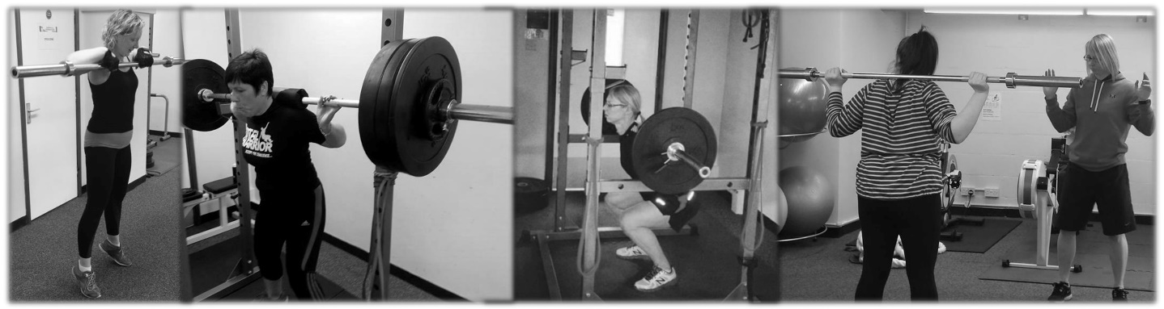
Here at Train Together we care about you. We want to help you reach your goals and make sure that you see the results you deserve. Our sole aim is to help you to get fit, gain confidence and feel really good about yourself again.
Every client we welcome to a personal training package gets something a bit different, because we understand how different everybody is. You are different from John, John is different from Mary and Mary is different from Dave. There is no ‘set personal training package’ with us and, at Train Together, one size definitely doesn’t fit all. We love to work closely with clients, identifying exactly what you are struggling with and how we will overcome these problems together. We are genuine trainers and our attitude is always friendly, supportive and encouraging. We set realistic goals and celebrate with you when you reach them. We take time and effort to ensure that you are happy and, most importantly, enjoying yourself! Contrary to popular belief, getting fit can be fun and we would love to be able to take you on its journey.
If you are ready to take the step (the first one is always the hardest, trust us) get in touch. We would love to chat with you about our personal training packages and discover how we can make you feel like you again.
Our 1-2-1 bespoke training is designed specifically for you, with guaranteed results tracked by our monthly body MOT. Included in your package is nutritional advice, plan and support. Our personal training sessions can now be enjoyed with a group of friends! Check out our website for more information.
John, Nov 2014
OUR PROGRAMMES

Boot Camp and Strength & Conditioning
Get your body in shape!
Boot Camps (warmer, outdoor months)
Our boot camps are guaranteed to help you lose weight and tone up.
6am Sunrise Boot Camps every Tuesday and Thursday to weekend Boot Camps. Our fantastic team at Train Together love creating fun and exciting sessions for you every week: from tractor tyre flipping to school yard games, every boot camp will be different and is guaranteed to get your whole body moving in all the right ways!

Strength & Conditioning (cooler, indoor months)
Same times as the Boot Camps but indoor sessions, with an emphasis on getting you stronger and building muscular endurance.

Stronger by TT Programme – for Ladies and Gents!
The basic package is 8 Weeks with 3-4 sessions per week, aiming to increase strength by up to 20%. To get the maximum benefit, sign up for our 14 Week programme, guaranteeing even greater strength gains. During the muscle up programme you will develop your strength by working on a tried and tested system, utilising 8 weight lifting movements. This programme is suitable for all ages, abilities and fitness levels. Contact Neil to find out more and get signed up on our next programme!

TESTIMONIALS
“I started going to Train Together at the beginning of December last year following major surgery a few weeks earlier. The surgery was followed up by nearly 6 months of Chemotherapy. My wellbeing and fitness levels have been maintained and improved thanks to the wonderful support and encouragement I have received from Neil, Sarah and Anna. I felt and still feel cared for too. I would not be this well in either mind or body without you all. Thank you!!” – Kate

“Although over 70 years of age, I needed to lose weight and get in shape for a mountain trek. With Sarah as a personal trainer for two hour long gym sessions a week over five months, and taking her expert advice on diet and exercise, I lost two stones and put on enough muscle to sail through 24,000 feet of ascent and one hundred miles of mountain walking over ten days. Those improvements to my weight and core fitness are now being maintained through twice weekly class sessions of weights and Boxercise with Neil and Sarah. More trekking beckons!” - John

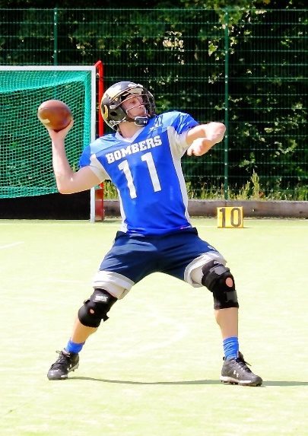
“The classes are great, they are enjoyable and every class is different which keeps it interesting. The social atmosphere is an added bonus, I have a good laugh when I am at TT, which helps battle through the exercises. Initially I joined because it is close to my workplace. However, regardless of this if I had tried it I would have joined anyway. It fits my work ethic perfectly – personal, challenging and the classes vary. I continue to beat my personal bests at the Train Together challenges – It’s hard not to be motivated when they are up on the board in front of you every class. It also makes it much easier to see the results. My highest recommendation. I have been to a lot of gyms in the area, and this is the only one that has kept my interest and I look forward to going to. Prior to this, the gym was an annoyance.” – Chris

“Training with Sarah and Neil has really changed my life. When I started, I was overweight and out of condition. In just under a year, I have gone through a real transformation. I now feel stronger and have lots more energy. When I started, I could only run for 30 seconds and needed a break. I now run for 40 minutes several times a week! Sarah and Neil are professional, supportive and most of all, great fun. They know just how far to encourage you to get the best performance out of you. They have a lot of experience, which comes across in their ability to bring out the best in you. I would recommend them to anyone, whatever their ability. Most of all, they are really nice people, which makes a difference, as the whole training experience becomes a pleasure instead of a chore.” – Nicola

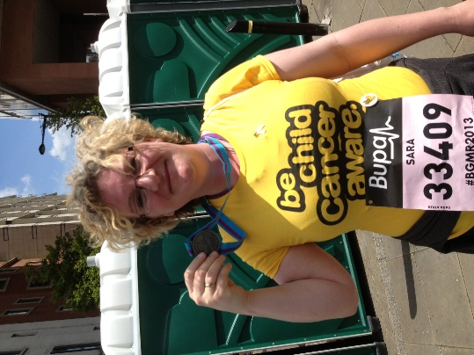
“I was attempting to exercise on my own and I was never sure if what I was doing was right or if it was being effective. I didn't enjoying working out and saw it solely as a means to an end – to lose weight and I hated every minute of it. This mental attitude impacted my motivation to exercise which in turn impacted upon my confidence and self-worth and as soon as I stopped exercising weight started to creep back on. You hear horror stories of what personal trainers can be like – uber fit gym bunnies who love to make fatties like me cry or drill sergeant majors who would shout and point at me. I was worried that I would not be fit enough to work out one to one, that I would make a fool of myself and that they would tell me to leave and never darken their door again. I thought working in a large class was the way forward as I could hide at the back. I can honestly say that since I started working with you, I really enjoy working out now – I feel confident with your instructions, you are always clear and concise, you constantly check form and posture so I know I won't get injured. I have always found core work difficult and if I struggle with an exercise, you always suggest an alternative. By doing this you make sure that I never feel silly or feel like I have failed and this has boosted my confidence. Thanks to your varied routines I have discovered that I enjoy Boxing, Kettle Bells and Rowing – none of this exercises I would have ever considered trying before. You are friendly, encouraging, you make exercising fun and no question is too daft to ask. I have definitely experienced weight loss and inch loss and have gained muscle definition but one of the major results for me is a change in my mental attitude – I look forward to exercising now, I have confidence to try new things and I no longer try and hide at the back of the class.” – Sara

“Before working with Neil I didn't have an exercise program and I had held off doing much exercise so as not to damage my back further after a back injury 18 months earlier.
An MRI scan revealed I had 2 squashed discs and surgery was the only option, after holding off, it later turned out this wasn't the case and arthritis is more likely. I decided to leave the NHS alone and to get on with strengthening my back and core with the aid of an expert. Having never had a personal trainer I wasn't sure what to expect. My only reservations were that I wanted to be treated on an individual basis. Which has been spot on.
Neil is very good to work with. From an initial assessment and discussion of what I felt I needed, it has been good to see that Neil has fulfilled my objectives and gone further by discovering the roots of muscle issues seemingly going back many years, then coming up with exercises to strengthen these and increase flexibility. Unlike an hour spent with a physio, I walk out of each session feeling energised rather than beaten up! I've learnt more about how and why muscles do things working with Neil than in all my time doing PE at school. I'm fitter. Cardio vascular is vastly improved. I can do so much more without feeling tired. I'm stronger, in better shape and my lower back has improved to a point where it is better than before my injury. Neil always varies the sessions. We never do the same session twice, it’s never been boring, and if Neil can see that I'm not up to something he will change the exercise immediately without having to think about it, a skilled fine line between pushing me and not breaking me.” - Greg

“I have been attending Sarah’s classes for a couple of years now and I have never been to a bad one! Sarah has in depth knowledge of all types of exercise and she is keen to share it with anyone who is interested. I had back surgery 18 months ago and Sarah encouraged me to continue exercising to aid my recovery. My recovery would not have been anywhere near as good without her knowledge and help. She is always supportive and takes time to ensure you are confident in what you are doing, whilst making the whole experience challenging and enjoyable. Sarah does a variety of different ‘style’ circuits that are all equally as challenging and enjoyable, but focus on different things. It is impossible to get bored, or lose motivation, during her sessions as she joins in and encourages everyone to do their best. She can always offer an easier or harder version of whichever exercise we are working on, which enables anyone – regardless of their level of fitness – to partake in her sessions. She is truly an inspiration, and I would recommend her classes to anyone.” - Sarah

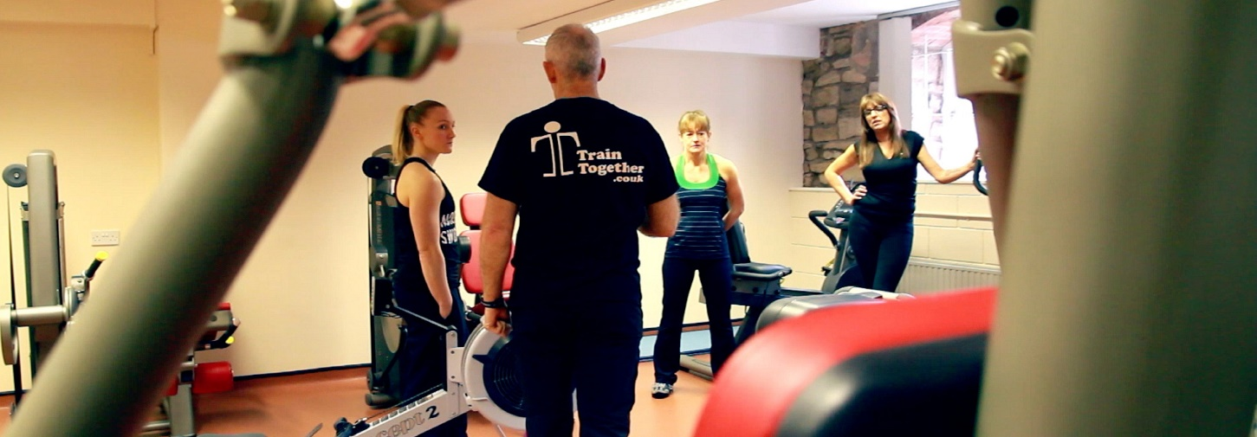
OUR FITNESS COURSES

Did you know that you can qualify as a fitness instructor with Train Together?
That’s right! We can help you to achieve all the relevant qualifications and experience needed to kick-start your fitness career in the best possible way.
Our courses include:
- Level 2 Certificate in Fitness Instructing – Gym Based
- Level 3 Personal Trainer Qualification
Our courses are blended learning, meaning that you can learn both in our studio and in the comfort of your own home! Courses are taught over weekends (Saturday-Sunday) or as an Intensive Monday to Friday Course. You can be fully qualified in as little as 8 weeks. Plus, as a local provider, you can enjoy the added bonus of not having to travel to Manchester and beyond for assessments and exam days.
If you are interested in one of our courses or for some further details, please contact our tutors. We would be very happy to answer your questions!
“Neil and Sarah did an excellent job. They were friendly and approachable. Explained the material clearly and went out of their way to help me in difficult/stressful times. The facility is a great place to train and meet new people. Nothing but positive feelings. Would recommend to anyone. Great course, very good value for money.” - Aaron

FIRST AID AND MANUAL HANDLING COURSES
At Train Together our aim is to provide the highest quality training at the most affordable price. Based in Lancaster, we are a friendly training facility with years of invaluable experience.
Our courses are primarily taught at our studio. However, for group bookings we are happy to provide any of our courses at the venue of your choice. We offer weekday training, weekend training and the opportunity to split up your course into more manageable chunks. If you would like any further details or to book onto an upcoming course, please get in touch with us via email (info@traintogether.co.uk) or telephone (01524 389616).
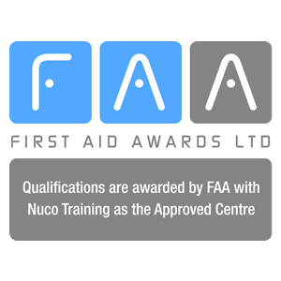
What do we offer?
Level 2 CPR and AED Training – 1 day – £60
Level 2 Emergency First Aid at Work – 1 day – £60
Level 3 Emergency Paediatric First Aid – 1 day – £60
Level 3 Paediatric First Aid – 2 days – £120
Level 3 First Aid at Work – 3 days – £160
Level 3 First Aid at Work Requalification – 2 days – £120
Children’s First Aid Awareness (Mini-Medics) - £10 for 3 hours of fun and education
Annual First Aid Refresher – 1 day – £60
Manual Handling – 1day – £60

“The Emergency First Aid at Work course was brilliant and I would recommend it to anybody. I took part to brush up on my knowledge and now feel prepared and confident to handle an emergency effectively. Sarah was a fantastic tutor, very thorough and very friendly. Having done this course elsewhere, I can honestly say that it was the best First Aid course I have been on!” Anna.
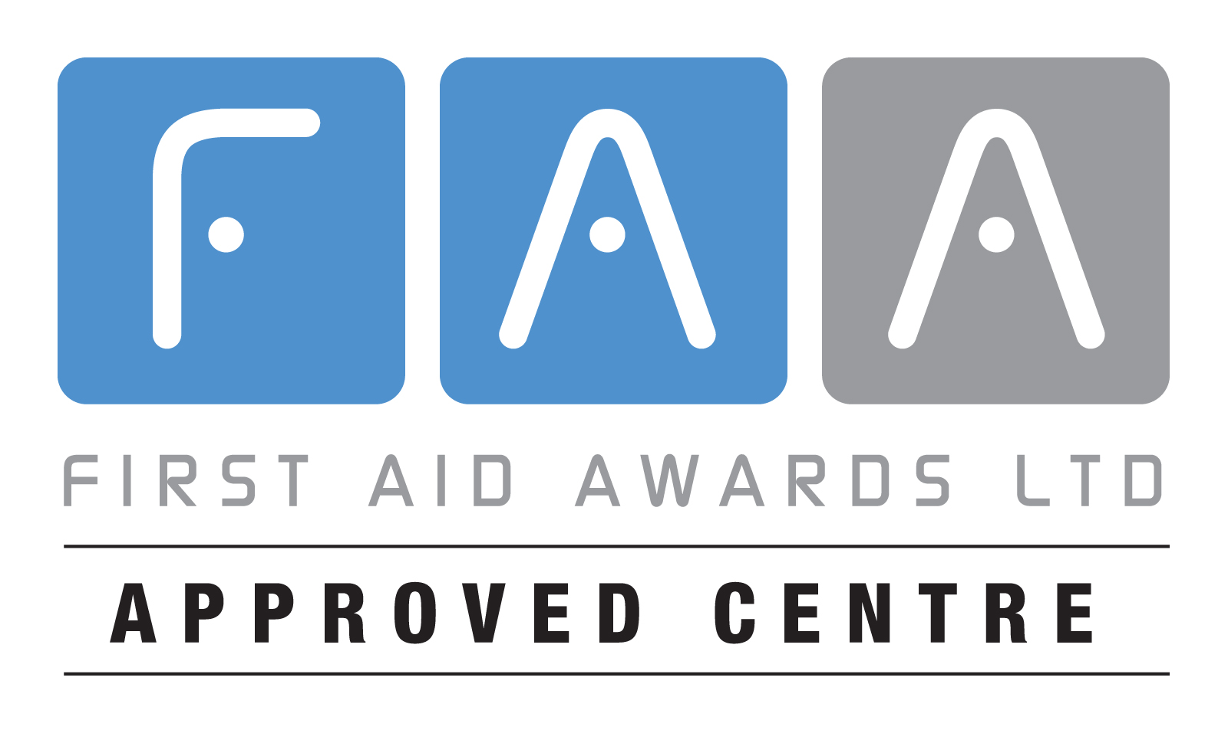
HOW TO FIND US
Quarry Road (passing the White Cross Pub) - pass the Adult college on your right, take the first right and we are the building on the left
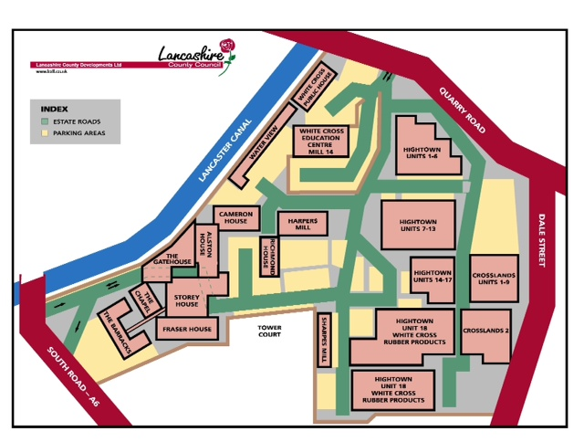
South Road (opposite the RLI) – enter the estate passing the White Cross Reception on your left, exit the tunnel and turn left into a U-shaped car parking area. We are in the top left of the car park (if your back is to the RLI)
Train Together Functional Fitness Studio
Harper’s Mill
White Cross Business Park
Lancaster
LA1 4XQ
01524389616 / 07725482701
info@traintogether.co.uk

